**The National Institute of Engineering**

(An Autonomous Institution under Visvesvaraya Technological University, Belagavi)

**Mysuru-570008**



DISSERTATION

ON

**“VISIBLE LIGHT COMMUNICATION BASED FILE DELIVERY SYSTEM”**

Submitted in partial fulfillment for the award

of

BACHELOR OF ENGINEERING

IN

**“ELECTRONICS AND COMMUNICATION”**

For the academic year 2018-2019

|  |  |
| --- | --- |
| **Submitted by:** |  |
| **AKHILESH C GUDDAD** | **4NI15EC008** |
| **ASHWIN T R** | **4NI15EC022** |
| **BASAVARAJ R SUNAGAD** | **4NI15EC025** |
| **MANAV GURUMOORTHY** | **4NI15EC056** |

**Under the guidance of**

**Dr. Rohini Nagapadma**

**Professor, Dept. of ECE**



**THE NATIONAL INSTITUTE OF ENGINEERING**

**Department Of Electronics and Communication Engineering**

**Mysuru- 570008.**

**2016-2017**

**THE NATIONAL INSTITUTE OF**

**ENGINEERING**

**Department of Electronics and Communication**

**Mysuru -570008.**



**CERTIFICATE**

This is to certify that the project entitled **“HOME SURVEILANCE SYSTEM”**

has been successfully completed by **ADARSH PRABHAKAR CHANTAR**

**(4NI13EC002), CHARAN G BHAKTHA (4NI13EC012), MANJUNATH S G**

**(4NI13EC026), MANOJKUMAR H M (4NI13EC027)** of 8thsemester B.E. whocarried out the project work under guidance of “**DR.NARASIMHA KAULGUD”** in the Partial fulfillment for the award of degree of Bachelor Engineering in Electronics and Communication Engineering of Visvesvaraya Technological University, Belagavi during the year 2016-17. It is certified that all corrections/Suggestions indicated during internal assessment have been incorporated in the report. The Project has been approved in partial fulfillment for the award of the said degree as per academic regulations of the National Institute of Engineering (An Autonomous Institution under Visvesvaraya Technological University, Belagavi).

|  |  |  |
| --- | --- | --- |
| **Dr.Narasimha Kaulgud,** | **Dr.Rohini Nagapadma,** |  |
| **Ph.D.,** | **Ph.D.,** |  |
| Project Guide, | Head of the Department, | Principal, |
| Department of ECE, | Department of ECE. | NIE, Mysuru. |
| **Name of the Examiners** |  | **Signature with Date** |

**1.**

**2.**

**ACKNOWLEDGEMENT**

We would take this opportunity to express our sincere gratitude and respect to lot of eminent personalities. Without whose constant encouragement and gratitude, the project of ours wouldn’t become reality.

We are grateful to **Dr. Rohini Nagapadma**, HOD, Department of Electronics and Communication Engineering, NIE Mysore for her support facilitating the progress of this work.

We sincerely extend our thanks to our guide **Dr.Narasimha Kaulgud**, Professor, Department of Electronics and Communication Engineering, NIE Mysore for their valuable guidance, constant assistance and support for the betterment of this project.

Our hearty thanks to our friends, non-teaching staff and all those other people who have supported us during the project.

**ADARSH PRABHAKAR CHANTAR**

**CHARAN G BHAKTHA**

**MANJUNATH S G**

**MANOJKUMAR H M**

**CONTENTS**

**Sl**

**Title**

**Pg. no.**

**ABSTRACT**

**LIST OF FIGURES**

**LIST OF ACRONYMS**

**i**

**ii**

**iii**

* **INTRODUCTION**

|  |  |  |  |  |
| --- | --- | --- | --- | --- |
| 1.1 | Overview | |  | 1 |
| 1.2 | Tool Set | |  | 3 |
|  | 1.2.1 | Camera |  | 3 |
|  | 1.2.2 | Python |  | 4 |
|  | 1.2.3 | OpenCV |  | 4 |
|  | 1.2.4 | Raspberry Pi | | 5 |
|  | 1.2.5 | Gmail |  | 6 |
| 1.3 Basics of digital image | | | | 6 |
|  | 1.3.1 | Digital Image | | 6 |
|  | 1.3.2 | Types of Images | | 7 |
|  |  | 1.3.2.1 | Binary Image | 7 |
|  |  | 1.3.2.2 | Gray-scale Image | 7 |
|  |  | 1.3.2.3 | Colour Image | 8 |
|  | 1.3.3 | Morphological Operations on Images | | 8 |
|  |  | 1.3.3.1 | Erosion | 9 |
|  |  | 1.3.3.2 | Dilation | 9 |
|  | 1.3.4 | Image Smoothing Techniques | | 9 |
|  |  | 1.3.4.1 | Normalized Box Filter | 10 |
|  |  | 1.3.4.2 | Gaussian Filter | 10 |
|  |  | 1.3.4.3 | Median Filter | 10 |

* **MOTION DETECTION**

|  |  |  |
| --- | --- | --- |
| 2.1 | Introduction | 11 |
|  | 2.1.1 Terminologies used | 11 |
| 2.2 | Implementation | 11 |
| 2.3 | Working | 14 |

* **FACE DETECTION AND RECOGNITION**

|  |  |  |  |  |
| --- | --- | --- | --- | --- |
| 3.1 | Introduction | |  | 18 |
| 3.2 | Implementation | |  | 18 |
|  | 3.2.1 | Overview | | 18 |
|  | 3.2.2 | Haar Cascade Classification | | 19 |
|  | 3.2.3 | LBPH Face Recognition | | 22 |
|  |  | 3.2.3.1 | Introduction | 22 |
|  |  | 3.2.3.2 | Algorithmic Description | 23 |
| 3.3 | Working | |  | 26 |
|  | 3.3.1 | Working of BuildData and Training | | 26 |
|  | 3.3.2 | Working of Face Recognition | | 29 |

* **SENDING NOTIFICATION**

|  |  |  |
| --- | --- | --- |
| 4.1 | Introduction | 34 |
| 4.2 | SMTP and MIME | 34 |
| 4.3 | Working | 35 |
| **5 RESULT AND SUMMARY** | | 37 |

* **CONCLUSION AND FUTURE SCOPE**

|  |  |  |
| --- | --- | --- |
| 6.1 | Conclusion | 39 |
| 6.2 | Future work | 39 |
| **REFERENCES** | | 40 |

**ABSTRACT**

As conventional communication techniques are reaching its limit in terms of bandwidth, there is a need to explore ways which can overcome the limitations of the current communication techniques. In most cases, the limiting factor for high data rates tends to be the bandwidth of the system. Signiﬁcant research efforts have been made towards eliminating this drawback of traditional systems while not causing any degradation in the quality of service. This has led to exploring the unused regions of the electromagnetic spectrum to make the switch from RF spectrum and its limited bandwidth. Visible light as a medium of communication is an ideal candidate due to its seemingly infinite bandwidth. Such a method of communication where visible light itself is a medium for data transfer is called Visible Light Communication (VLC). Our research demonstrates the same.

Page | i

**LIST OF FIGURES**

|  |  |  |  |
| --- | --- | --- | --- |
| **Sl** |  | **Figure Name** | **Page. no.** |
| 1 | 1.1 | Home Plan of Surveillance | 2 |
| 2 | 1.2 | Block diagram of Home Surveillance System | 2 |
| 3 | 1.3 | Logitech c170 USB Camera | 3 |
| 4 | 1.4 | Raspberry Pi 2 model B | 5 |
| 5 | 1.5 | Example for Binary image | 7 |
| 6 | 1.6 | Binary image intensity levels | 7 |
| 7 | 1.7 | Example for gray-scale image | 8 |
| 8 | 1.8 | Gray-scale image intensity levels | 8 |
| 9 | 1.9 | Example for colour image | 8 |
| 10 | 2.1 | Flowchart of Motion Detection | 13 |
| 11 | 2.2 | Image of the room when there is no motion | 17 |
| 12 | 2.3 | Image of the room when motion is detected | 17 |
| 13 | 3.1 | Features of Haar cascade | 20 |
| 14 | 3.2 | Applying line and edge features on a image | 21 |
| 15 | 3.3 | LBP operator with 3x3 neighborhood | 23 |
| 16 | 3.4 | Variable neighborhood in LBPH | 24 |
| 17 | 3.5 | LBP image of an artificially modified image | 25 |
| 18 | 3.6 | Flowchart for BuildData and Training | 26 |
| 19 | 3.7 | Flowchart for face detection and recognition | 29 |
| 20 | 3.8 | Image when face of the owner is recognized | 33 |
| 21 | 3.9 | Image when intruder is detected | 33 |
| 22 | 4.1 | Range of SMTP protocol | 34 |
| 23 | 4.2 | Flowchart for sending notification | 35 |
| 24 | 5.1 | Complete Project Module | 37 |
| 25 | 5.2 | Image of email notification upon motion detection | 37 |
| 26 | 5.3 | Image of email notification upon face recognition | 38 |
| 27 | 6.1 | Application to control Home Surveillance System | 39 |
|  |  | that could be developed |  |

Page | ii

**LIST OF ACRONYMS**

* ARM – Advanced RISC Machine
* ASCII – American Standard Code for Information Interchange
* CCTV – Closed Circuit Television Cameras
* CRT- Cathode Ray Tube
* CSI – Camera Serial Interface
* DSI – Discrete Stream Interface
* ESMTP –Extended Simple Mail Transfer Protocol
* GCC – GNU Compiler Collection
* Gmail – Google mail
* GPIO Pins – General Purpose Input Output Pins
* GUI – Graphical User Interface
* HDMI – High Definition Multimedia Interface
* IMAP – Internet Message Access Protocol
* LBPH – Local Binary Patterns Histograms
* LCD –Liquid Crystal Display
* MIME – Multi-purpose Internet Mail Extensions
* MTA – Mail Transfer Agent
* NVT ASCII – Network Virtual Terminal ASCII
* Open CV – Open Source Computer Vison
* POP – Post Office Protocol
* RISC – Reduced Instruction Set Computer
* SD – Secure Digital
* SMTP – Simple Mail Transfer Protocol
* TLS – Transport Layer Security
* USB –Universal Serial Bus
* XML – Extensible Markup Language

Page | iii

Home Surveillance System

1. **INTRODUCTION**

**1.1. OVERVIEW**

The visible light spectrum is the portion of the electromagnetic spectrum that is visible to the human eye. Electromagnetic radiation in this range of wavelengths is called visible light or simply light. A typical human eye will respond to wavelengths from about 390 to 700 nanometers. In terms of frequency, this corresponds to a band in the vicinity of 430–770 THz (Tera-hertz).

Visible light communication is a method of data transfer using visible light spectrum. The visible light spectrum has a bandwidth spanning 100s of THz which is 10000 times larger than the RF bandwidth.

VLC has numerous advantages over conventional methods, such as higher data rates, larger bandwidth, higher security, lower power consumption. Experiments done in VLC have achieved a data rate of 1Gbps under laboratory conditions. By using visible light, it is intended to achieve wireless communication in environments where it is not convenient to use Radio Frequency(RF) waves like in airplanes, hospitals etc. [4].

In VLC, the light source is typically a Light Emitting Diode (LED). Here LEDs are used for data transmission and offers illumination simultaneously. The main principle of this communication system is to switch ON and switch OFF a light source at a high rate, where the ON and OFF states of the light represent binary 1 and binary 0 respectively. By making the switching rate higher than the persistence of vision for humans, the light appears to be continuous in nature. Due to this continuous switching the overall brightness of the light decreases. The receiver works by looking out for the rapid changes of the light that represent data, thereby creating a line of sight communication link between the transmitter and the receiver.

VLC can potentially have a very large bandwidth but it is plagued by certain limitations owing to its physical components. At the transmitter, a white LED is used as a source of light. The limitation in bandwidth arises by the method in which the LED produces white light. At the receiver, the photodiode contains parasitic capacitances which limit the bandwidth of the VLC system. Ambient light interference introduces noise in the channel which affects system performance. The operating range is further limited by sensitivity of the photodiode.

Having studied and understood the capabilities and limitations behind this technology, our research attempts to build a functional visible light communication system to allow basic data transmission between two communicating nodes.

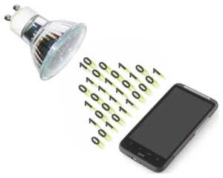

**1.2. TOOL SET**

**1.2.1. ARDUINO UNO:** The Arduino Uno is an open source microcontroller based on the ATMega328p chip. It has a wide variety of on-board Input/output options including Digital I/O, Analog I/O and PWM outputs. The Arduino board is programmed using the Arduino IDE which is written in Java and based on other open source software. The board as well as the IDE was developed by Arduino.cc with a goal to provide an easy and efficient tool for prototyping. More information about the same can be found at [8].

Given its low cost and versatility it was the ideal choice for the project. In the project we use the Arduino Uno as an interface between the transmitting node and the light source and it helps to modulate the data onto the light. Another Arduino Uno is used at the receiver that act as an RS232 communication interface between the receiver front end circuit and the receiving node.

**PYTHON:** Python is a widely used general-purpose interpreted, objected-oriented, and a high-level programming language designed by Guido van Rossum and developed by Python Software Foundation. Python is user-friendly, easy to learn and has thousands of third-party modules and can integrate systems quickly, making it one of the most used programming languages among the diverse and international community of programmers and developers. A detailed explanation can be found at [9].

With its huge collection of libraries and interfaces, Python has proved to be the apt choice for image processing and file handling in our project. Python is used as a wrapper to control the flow of execution of programs including, reading data from files on PC, running shell commands for serial communication between the PC and the Arduino board, reading data from files and reconstruction of image from raw bit values using OpenCV [11].

**OpenCV:** OpenCV (Open Source Computer Vision), started by Intel in 1999, is the leading open source library for applicaions such as computer vision, image processing and machine learning. OpenCV is known for making use of multi-core processing for its computational efficiency, especially in real-time applications.

To transfer images through a VLC system, we need a powerful tool capable of converting images to raw pixel values to be encoded on the tranmitter side and reconstruction of images from the received and decoded pixel values on the receiver side. OpenCV is the most suitable tool for our application, given its open source nature and online community support.

  
**PROCESSING:** Processing is a software which focuses on writing code within the domain of the visual arts. It has a wide variety of APIs focusing on creating graphics. It also has APIs that allow for communication with the Arduino IDE. Details about Processing can be found at [12]. It is this functionality that we looked to exploit in our project. We used processing to be able to select files from the computer and send it to the Arduino which would in turn send the file in the visible light channel. Though we didn’t use processing in our final implementation it helped us to gain insights that were valuable in the progression of the project.

**LTspice:** A Simulation Program with Integrated Circuit Emphasis or SPICE is a class of software used to simulate the characteristics of an electronic circuit. LTspice is a high performace SPICE simulation software schematic capture and waveform viewer for the simulation of analog circuits [13]. We have extensively used LTspice

1. **APPROACH**

In our approach to implement a VLC system, we have established communication between two computers. The basic principle is that the transmitter side is made to drive an LED connected to one of the digital output pins of the arduino. The LED toggles ON and OFF based on the pulse received from the digital pin. The receiver uses a photodiode in reverse bias which produces current variations proportional to the received signal. These variations in current need to be further processed to obtain digital voltage signals that represent the data being transmitted.

## Untitled Diagram (1)**Transmitter**

Figure 1. Block diagram for Transmitter.

## Transmitter Software

For the transmitter, feeding in serialized data isn't an ideal way to send the data across the visible light channel. This is because typically data consists of HIGH (1) and LOW (0) bits in which the number of 0s maybe higher. This causes two problems: the first is that due to an increase in the number of transitions in the state of the led, there is a discernable flicker from the source which is not desirable; secondly, the overall brightness of the source drops below 50% as the time that the LED is ON is less than half of the total time. An encoding format is used to overcome the same. A modest way to encode the data is to use Manchester encoding, in which each data bit is encoded as a transition from low to high, or high to low, for an equal duration of time. Here a bit valued ‘1’ is encoded as a signal going from HIGH state to LOW state and a ‘0’ is encoded to a signal going from LOW state to HIGH state. The Manchester encoded data prevents the reception of consecutive 0s. As a result, the LED brightness is not adversely affected. The encoding scheme used also helps reduce flickering and it is not visible to the naked eye.

Since we use asynchronous serial communication, framing is essential for reliable communication. Framing typically involves the addition of two special flags called delimiters that are added to the start and the end of a data segment. In our implementation we have used 0x03 and 0x02 for the start and stop bits respectively. Additionally, asynchronous communication requires data synchronization between the sender and receiver and this is achieved by a synchronization byte 0xD5 [1].

In order to transfer files from a computer to the microcontroller, a software overlay is needed to read from the file and push the data onto the Arduino through an RS232 interface. Probing into the possible solutions has resulted in exploring multiple programming language options including C++, python, java and C# and softwares including MATLAB, Processing and Microsoft Visual Studio. The selection of software depends on the trade-off between speed, efficiency and ease of use. While python offers diverse ready to use APIs, C++ promises speed and ease of bit manipulation. Similarly, reading various files from the computer proves to be easier on C# (run on Visual Studio) than on Processing (based on Java).

## Transmitter Hardware

The principle of data transmission in VLC is to turn ON and turn OFF a light source in correspondence to the transmitted bits. The transmitter in our system consists of a high power white LED (12 Watts) and a MOSFET switch. This is interfaced to a computer (data source) using an Arduino Uno board that provides the RS-232 interface. Data from the computer is sent to the arduino through UART where it is processed and encoded. The processed data is sent to the driver circuit through a digital output pin in the form of bits.

The driver circuit for the transmitter is a MOSFET switch. We use an N-channel MOSFET with a typical threshold voltage (Vtn) of 4V. The logic levels of the microcontroller is 0-5V. Which means that the logic high output of the Arduino can fully turn on the MOSFET. The MOSFET circuit is used to rapidly switch the LED ON and OFF corresponding to the data output by the controller to the gate of the MOSFET. In the figure voltage V1 represents the output data bits from the controller and D1 represents the LED source that is being switched.

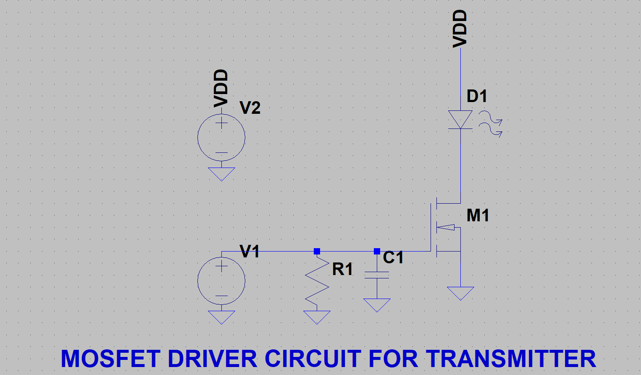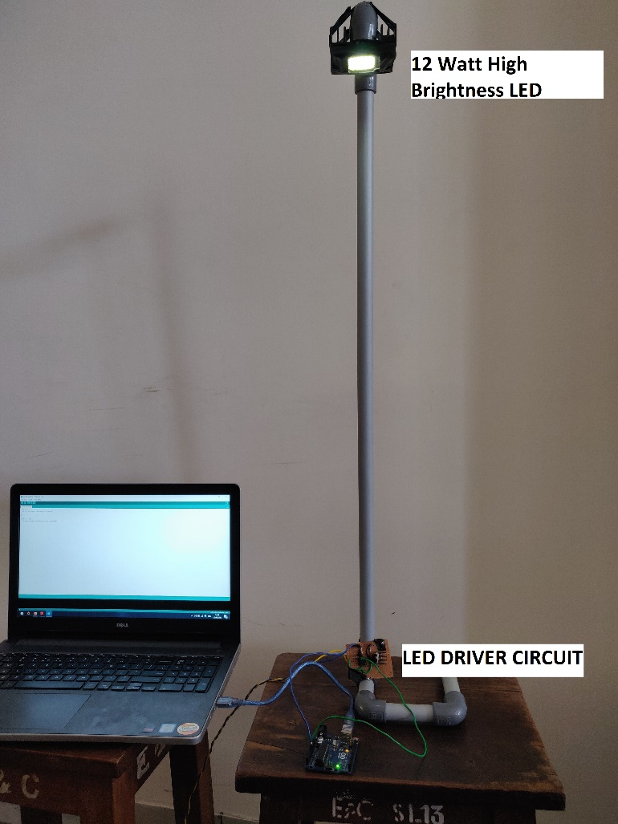

Figure 2. Experimental setup of Transmitter; the setup consists of High Power LED source, LED driver circuit and micro-controller.

## **Receiver**

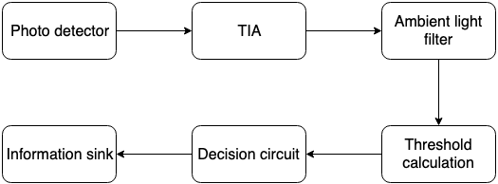

Figure 3. Block diagram of Receiver

## Receiver Software

The digital signals from the receiver front end circuit are read by the digital pins of the Arduino. The signal being a digital PWM wave, it is necessary to identify the rising and falling edges of the signal to differentiate HIGH (1) and LOW (0) levels to convert the digital signals into a bit stream. To achieve this, the received digital signals are sampled at an appropriate frequency and a symbol period is calculated. If the signal is found to be steady for longer than a single symbol period, the data is considered valid and the receiver starts receiving.

The continuous stream of alternating 1s and 0s sent by the transmitter to keep the LED ON is ignored and the receiver only starts reading data when it encounters a synchronization byte. The receiver then removes the start delimiter and extracts data until the stop delimiter is reached. The buffer limit of 64 bytes on an Arduino board is hard coded into its firmware source code. Larger data sent to through the buffer gets truncated, thus imposing a limiting factor on the size of each frame.

The data extracted from each frame is decoded from its Manchester form and coalesced into groups of 8 bits which represents a character. The Arduino then outputs the string of characters to the computer through its communication port.

## Receiver Hardware

At the receiving end, the photo-sensing element used is a PIN Photodiode which can sense high frequency variations in the intensity of light being transmitted. The photodiode produces electric current which is proportional to the intensity of light incident on it. This electric current is in the order of few micro-amperes and analog in nature. The micro-controller can only recognize digital voltage levels which necessitate the need for a frontend processing circuit.

The frontend processing circuit should be able to convert electric current to equivalent voltage levels, filter the ambient interference, calculate a reference and output the digital signals.

To decide on efficient receiver hardware, we have simulated and tested the following frontend circuits: DC restoration circuit [7], AC coupled circuit and AC amplifier circuit. After a thorough analysis of simulation results we have concluded that the AC coupled circuit is more reliable and efficient.

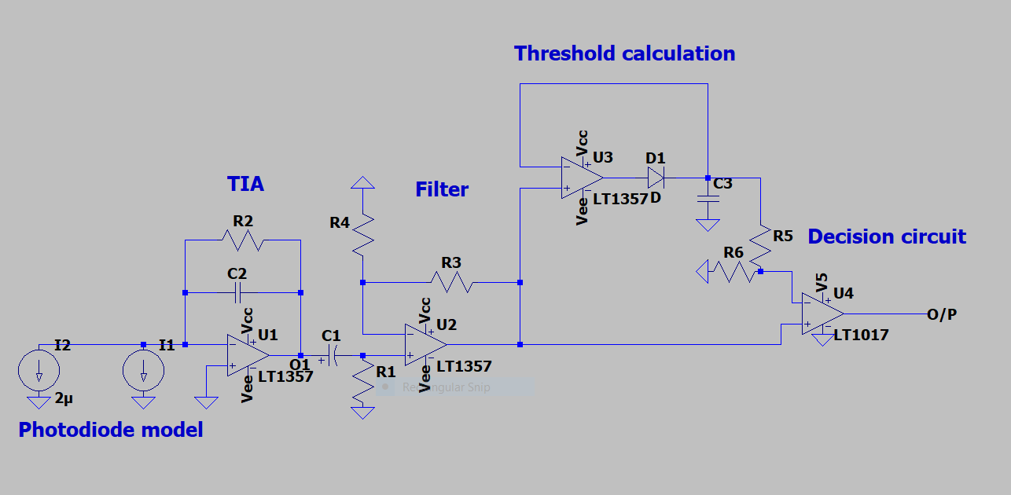

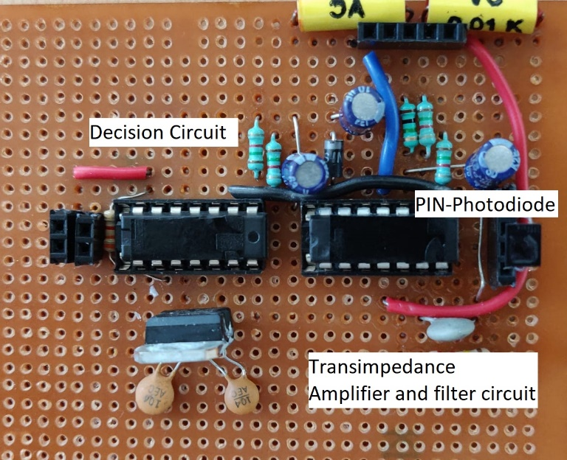

Figure 4. Frontend signal processing circuit for receiver; consists of PIN Photodiode as photo-detector, TIA stage, filter stage and decision stage. This circuit eliminates the need for a conventional ADC.

The first stage in the processing circuit is a Trans-Impedance Amplifier (TIA) which converts electric current into voltage levels. The design of TIA is very crucial as it sets the upper limit of bandwidth. It also plays a significant role in reducing the effects of junction capacitance of the photodiode. Second stage involves removal of ambient light interference. The ambient light produces a DC shift in the received signal which is eliminated by AC coupling. Third stage involves calculation of a suitable voltage level which is set as reference for the comparator. Last stage is the digitization of voltage levels which is achieved by using a comparator. The comparator compares signals from second stage with the reference and outputs digital voltage levels to be read by the micro-controller.

Results and Observations

The proposed system is capable of taking either a string or a text file as input. The data is then encoded and framed using the above mentioned frame format. The frames are fed bitwise to the LED driver circuit. The system is tested for reliable performance at a communication speed of 600bps with the transmitter and receiver separated by a distance of 6ft.

Initially, the receiver used the inbuilt Arduino ADC instead of a frontend circuit for signal conversion. Although the system was simple and reliable, the computationally intensive 10-bit ADC consumed more number of clock cycles and slowed down the communication speed. To overcome this limitation, the above mentioned receiver circuit was built and implemented.

Simulation of frontend circuit

Before realizing the frontend receiver hardware, an LTSpice model of the circuit was built and analyzed. Simulation was tested based on scenarios that the system was expected to encounter such as ambient light interference. The expected DC shift from the ambient light was seen at the output of the TIA. The filter stages and decision circuitry performed as designed and removed this shift to yield a near perfect digital signal as shown in Figure 5.

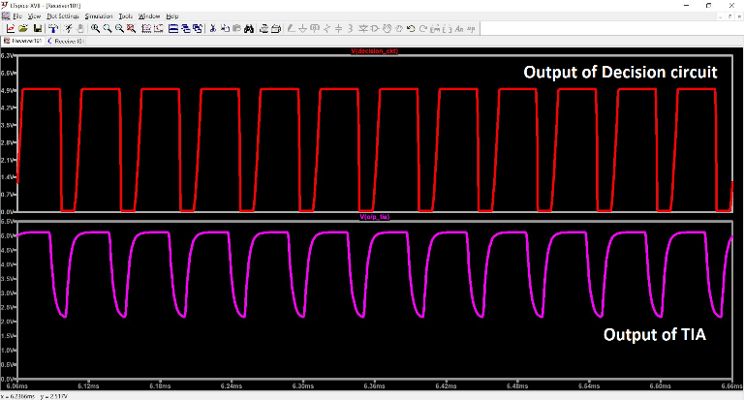

Figure 5. Simulation results of the frontend circuitry. Lower waveform shows the output of the TIA, with the DC shift from the ambient light interference. Upper waveform is the final expected output of the circuit.

Comparison of Simulation with Actual Results

The receiver frontend circuit was tested under various ambient lighting conditions. It was also tested at different separations and misalignments and was found to be reliable with no data loss or corruption.

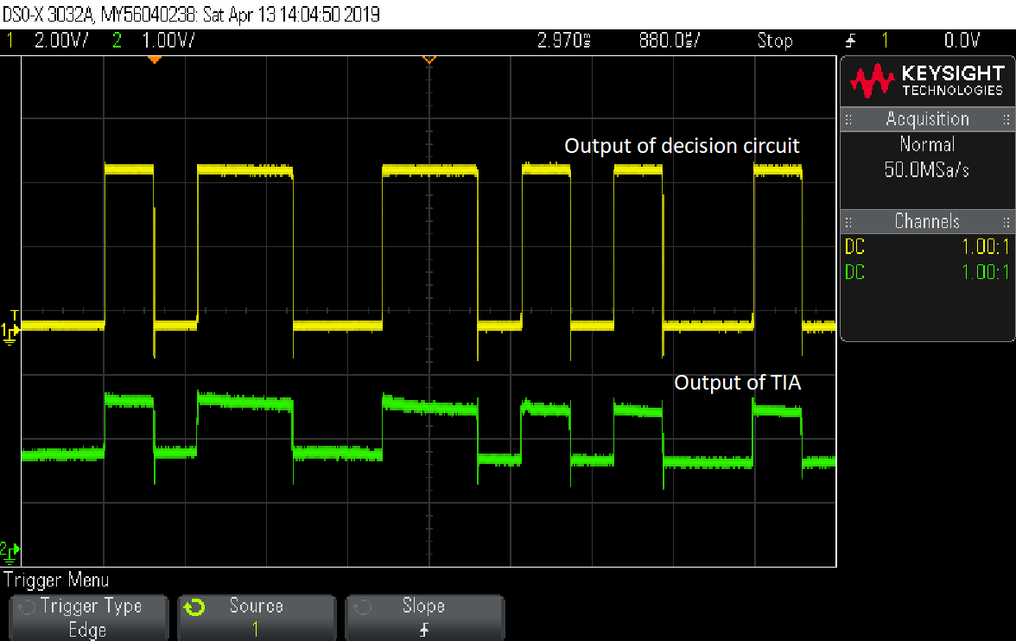

Figure 6. Output waveforms of frontend receiver circuit; top waveform indicating output of TIA and bottom waveform indicating output of decision circuit.

In Figure 6, we can see that the output of TIA is an analog signal with a DC shift of 1.5 volts. This signal is filtered and fed to the decision circuit whose output is represented by the upper waveform. We found that the actual results met the expectation set by the simulations.

Limitations

Though ideally it seems that VLC has a very large bandwidth it has its own limitations. Its bandwidth is limited by the typical elements involved which are LEDs and Photodiodes. At transmitter side a white LED is used as a source of light, the limitation in bandwidth arises by the method in which a LED produces white light.

White light is a mixture of Red, Green and Blue light. The RGB white method produces white light by combining the output from red, green and blue LEDs. This is an additive color method. But RGB white light is hardware-intensive, since it requires three LEDs, and it tends to render pastel colors unnaturally, a fact which is largely responsible for the poor color rendering index of RGB white light. The Phosphor white method produces white light in a single LED by combining a short wavelength LED such as blue or UV, and a yellow phosphor coating [6]. It is seen that the bandwidth is ~2MHz for the white, and ~10MHz for the blue component only [2]. This is due to the long decay time of the phosphor, and provides a limitation on the overall bandwidth available. In addition, the Blue LED die is not designed for high speed operation and is very large in area (and thus has high equivalent capacitance) compared with devices used for high speed communications. The limited bandwidth of the LEDs is therefore one of the major challenges for high-speed communications.

At the receiver, studying a model of the photodiode led to the discovery of a junction capacitance which adversely affects the bandwidth of the VLC system. Ambient light interference introduces noise in the channel which if large enough, saturates the photodiode current. The operating range is also limited by the sensitivity of the photodiode. Factors limiting the performance of the photodiode are the capacitance of the junction as well as the parasitic capacitance of the package. The reverse-biased PIN junction acts like a capacitor because charge can be stored in the P and N sides with the depletion layer acting as a dielectric. This junction capacitance is to be minimized by careful design of the diode structure for high speed performance. Most practical high speed diodes typically have sub Pico-farad capacitances. Minimizing the load resistance also improves the performance of the receiver as a whole but it is not a limitation of the diode itself, but is related to the receiver’s electrical design.

The transmitter circuit uses ON OFF Keying (OOK) to modulate the light source at a high frequency. However, OOK is more sensitive to additive noise, has a poor spectral efficiency and power efficiency. The Manchester encoding used having an equal number of ones and zeros offers only 50% efficiency.

FUTURE WORK

VLC requires the light source to be always ON. A robust transmitter can be designed which is capable of adapting it’s brightness by varying the intensity based on received signal strength and ambient conditions. A better substitution for Manchester encoding which has more number of 1s can increase the efficiency and also keep the light source ON for a longer duration. Alternate modulation schemes such as FSK and BPSK which provide better immunity to noise can be implemented. To obtain gigabit speeds and parallel transmissions, OFDM and optical MIMO techniques can be used [2].

In spite of having a robust receiver, there might be few errors in the data received. Hence performance of code has to be improved. This can be done by using better encoding techniques and including data bits for error correction. Multiple photo detectors can be used in parallel to increase the current generated, thereby increasing the transmission distance. Solar panel has a very large surface area compared to a photodiode; hence they receive large optical power. They also receive illumination from ambient light; the DC offset produced by ambient light in photodiodes being small cannot be harnessed but in solar cells the DC offset is large enough to be harvested. In this way a self-sustained receiver can be developed [5].

APPLICATIONS

VLC has the following implicit characteristics including high bandwidth, low power consumption, inherent security and non-licensed channels that have made it beneficial for practical use. Diverse application scenarios are as follows: Every modern day vehicle embodies LED headlights which can be used to implement VLC modules. Applications in this space include collision warning, lane change warning, traffic rule violation warning and pre-accident sensing. Devices and machines sensitive to electromagnetic interference (such as MRI scanners) can switch to VLC technology in hospitals to prevent interference with radio waves from other machines. Large volumes of data can be transferred with adequate security by establishing a connection between two mobiles pointed at each other. VLC can provide much higher data transfer rates than Wi-Fi or Bluetooth. VLC can be incorporated in passenger compartments of aircraft where radio is undesirable. LEDs in the cabin can also be used to provide multimedia streaming services and flight tracking details to passengers. RF signals do not work underwater. VLC devices can be used for short distance communication underwater between divers or submarines and the surface.

CONCLUSION

In this approach we see how a common light source such as an LED can be made to transmit data in a more efficient way than conventional methods. We are surrounded by numerous light sources, we hope that someday all those sources can be made to give dual functionality i.e. to perform as both a light as well as a data source with minimal modifications. Thus, scaling this technology globally is not a tedious task. We propose to develop an Integrated Chip (IC) that can be attached to existing light bulbs in order to make them a VLC transmitter. It is predicted that VLC could play a vital role in broadcast communication. In terms of security of data being transmitted, tapping the source is not a possibility. In our work in this field, having realized the implications that this technology would have in the way we communicate, we believe that this could revolutionize wireless communication.

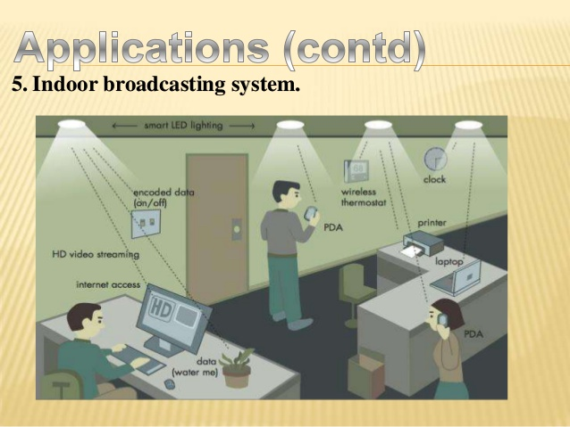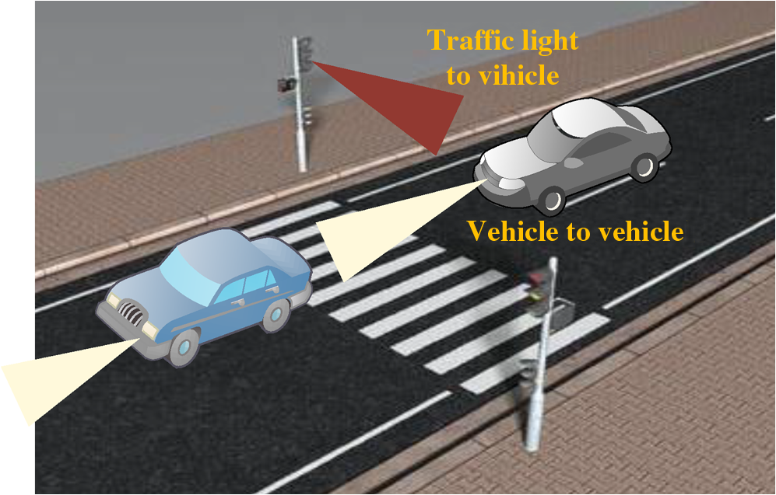

**References**

1. Piat Jonathan, Arduino simple Visible Light Communication, <https://github.com/jpiat/arduino/wiki/Arduino-simple-Visible-LightCommunication>
2. D. C. O’Brien, L. Zeng, H. Le-Minh, G. Faulkner, J. W. Wa lewski, and S. Randel, Personal, Indoor and Mobile Radio Communications, 2008. PIMRC 2008. IEEE 19th International Symposium on, 2008. “Visible light communications: Challenges and possibilities,” 2008.
3. A. E. Kelly, J. J. D. McKendry, S. Zhang, D. Massoubre, B. R. Rae, R. P. Green, R. K. Henderson, and M. D. Dawson, "High -speed GaN micro-LED arrays for data communications," in Transparent Optical Networks (ICTON), 2012 14th International Conference on, 2012, pp. 15.
4. H. Haas and C. Chen, European Conference on Optical Communication (ECOC), What is LiFi?, 2015
5. Zixiong Wang, Dobroslav Tsonev, Stefan Videv, and Harald Haas, IEEE journal on selected areas in communications, VOL. 33, NO. 8, AUGUST 2015, ”On the design of a solar panel receiver for Optical Wireless Communication and simultaneous energy harvesting”, 2015
6. Photon Star Technology Ltd., “How LEDs produce white light”

<http://www.photonstartechnology.com/learn/how_leds_produce_white_light>

1. Bonnie Baker, “Photo sensing with ambient background”, February 17 2011.

<https://www.edn.com/Pdf/ViewPdf?contentItemId=4364018>

1. What is Arduino? <https://www.arduino.cc/en/Guide/Introduction>
2. About Python, https://www.python.org/about
3. SoftwareSerial Library, <https://www.arduino.cc/en/Reference/SoftwareSerial>
4. OpenCV Wiki, <https://github.com/opencv/opencv/wiki>
5. processing, <https://github.com/processing/processing/wiki>
6. LTspice by Analog Devices, https://www.analog.com/en/design-center/design-tools-and-calculators/ltspice-simulator.html